Programming Lab 2  
Lab Assessment 4  
Batch: S4

2019BTECS00058  
Devang Kamble

1. Suppose in number.txt file some random numbers are stored (-ve/+ve/fractional number). Using JAVA program find how many numbers are –ve, +ve and fractional number.

Program:

NumberType.java

import java.io.FileNotFoundException;

import java.io.FileReader;

import java.io.IOException;

import java.util.*;

public class NumberType{

public static void main(String[] args) throws IOException

{

int ch;

FileReader fr=null;

ArrayList<String> al = new ArrayList<String>();

//get the file

try{

fr = new FileReader("numbers.txt");

}

catch (FileNotFoundException fe){

System.out.println(fe);

}

//get all numbers

String s = "";

while ((ch=fr.read())!=-1)

{

char c = (char)ch;

if(c=='\n')

{

al.add(s);

s = "";

}

else

{

s += c;

}

}

//final number of the file

al.add(s);

s="";

fr.close();

//parse all numbers and get required count

int count_positive=0, count_negative=0, count_fraction=0;

for(String st: al)

{

Double thatNum = Double.parseDouble(st);

if(thatNum < 0)

{

count_negative++;

}

else

{

//we assume 0 to be positive

count_positive++;

}

if(thatNum%1 != 0)

{

count_fraction++;

}

}

//printing output

System.out.println("For the Numbers in numbers.txt:\n");

System.out.println("Count of Positive Numbers: "+String.valueOf(count_positive));

System.out.println("Count of Negative Numbers: "+String.valueOf(count_negative));

System.out.println("Count of Fractional Numbers: "+String.valueOf(count_fraction));

}

}

Output:

Test 1:

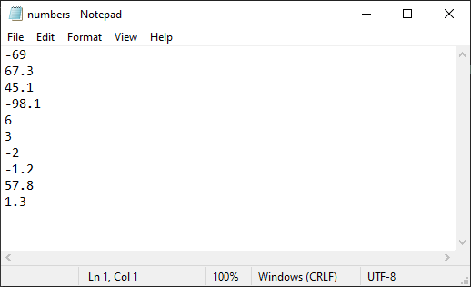

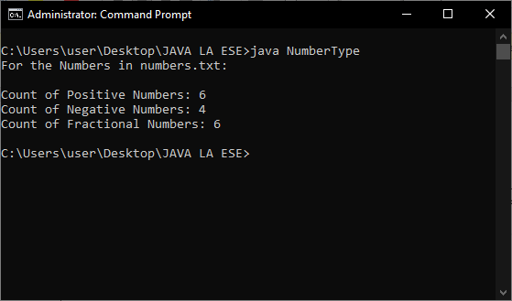

Test 2:

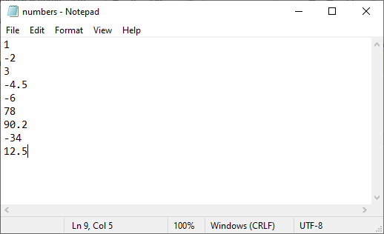

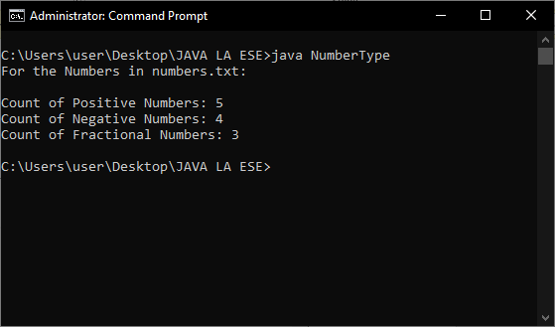

Test 3:

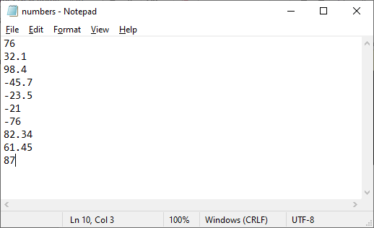

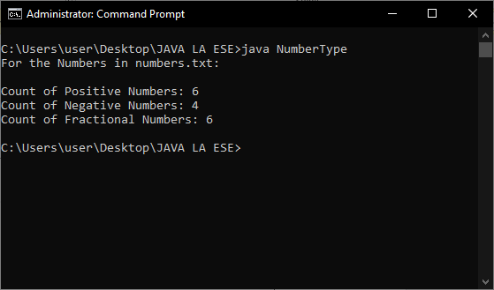

1. Design a java class to represent a bank account. Include the following members: Data Members- Name of the depositor, account number, type of account and balance in account. Methods - to assign initial values, to deposit an amount, to withdraw an amount after checking balance and to display account details.

Program:

BankAccount.java

public class BankAccount {

// data members

String depositorName, accountType;

long accountNumber, balance;

//we can use the constructor to assign initial values

BankAccount(String depositorName, String accountType, long accountNumber, long balance)

{

this.depositorName = depositorName;

this.accountType = accountType;

this.accountNumber = accountNumber;

this.balance = balance;

}

Boolean depositAmount(long amount)

{

this.balance += amount;

return true;

}

Boolean withdrawAmount(long amount)

{

if(this.balance >= amount)

{

this.balance -= amount;

return true;

}

return false;

}

long currentBalance()

{

return this.balance;

}

void accountDetails()

{

System.out.println("\nYour Account Details:");

System.out.println("Name of Depositor: "+this.depositorName);

System.out.println("Account Type: "+this.accountType);

System.out.println("Account Number: "+String.valueOf(this.accountNumber));

System.out.println("Current Balance: "+String.valueOf(this.balance));

}

}

BankDesk.java

import java.util.*;

import java.io.*;

public class BankDesk {

static int getRandomNumber(int min, int max) {

return (int) ((Math.random() * (max - min)) + min);

}

static void makeChoice(BankAccount ba)

{

Scanner sc = new Scanner(System.in);

System.out.println("\nChoose Your Action:");

System.out.println("1. Deposit Amount.");

System.out.println("2. Withdraw Amount.");

System.out.println("3. Get Account Details.");

System.out.println("4. Exit.");

System.out.print("\nYour Choice: ");

int choice = sc.nextInt();

if(choice==1)

{

System.out.println("\nEnter Amount to Deposit: ");

long amt = sc.nextLong();

Boolean resp = ba.depositAmount(amt);

if(resp == true)

{

System.out.println("Amount Deposited Successfully.");

System.out.println("Your current Account Balance is: "+String.valueOf(ba.balance));

}

makeChoice(ba);

}

else if(choice==2)

{

System.out.println("\nYour current Account Balance is: "+String.valueOf(ba.balance));

System.out.println("\nEnter Amount to Withdraw: ");

long amt = sc.nextLong();

Boolean resp = ba.withdrawAmount(amt);

if(resp == true)

{

System.out.println("Amount Withdrawn Successfully.");

System.out.println("Your current Account Balance is: "+String.valueOf(ba.balance));

}

else

{

System.out.println("Insufficient Balance. Try Again");

}

makeChoice(ba);

}

else if(choice==3)

{

ba.accountDetails();

makeChoice(ba);

}

else if(choice==4)

{

System.out.println("\nThank Your Using our Service.");

System.exit(1);

}

else

{

System.out.println("Inalid Choice. Try Again.");

makeChoice(ba);

}

}

public static void main(String[] args) {

Scanner sc = new Scanner(System.in);

System.out.println("-- Bank Account --\n");

System.out.print("Enter your Name: ");

String name = sc.nextLine();

System.out.print("Enter Account Type: ");

String type = sc.nextLine();

System.out.print("Enter Initial Balance: ");

long bal = sc.nextLong();

//randomly set an account number

int acntNum = getRandomNumber(200, 1200);

//object of the bank-account

BankAccount ba = new BankAccount(name, type, acntNum, bal);

makeChoice(ba);

}

}

Output:

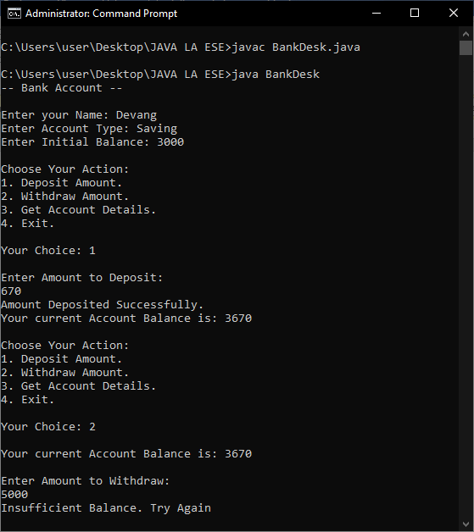

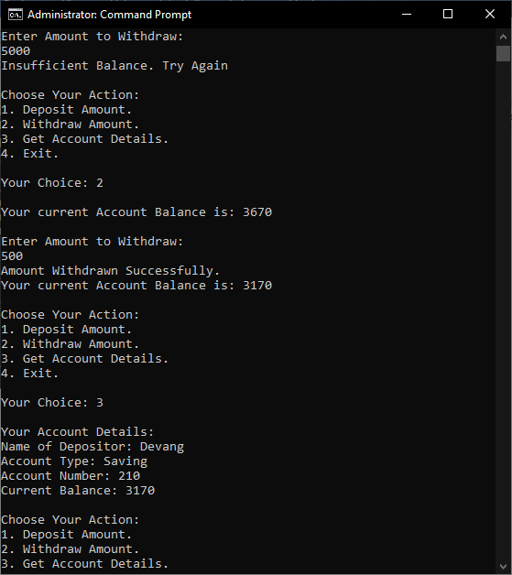

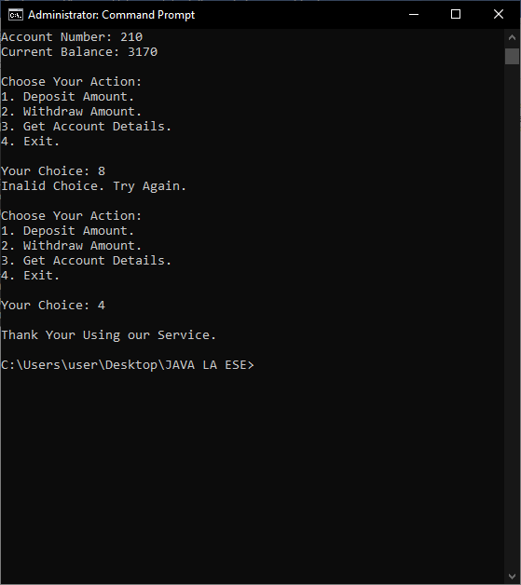

Drive Link for the Source Code Files: [Here](https://drive.google.com/drive/folders/1JYkhLnrcSSmjGuE_kxsCq1pdtbXk9FfZ?usp=sharing)